**Ripple factor of half-wave rectifier:**

Ripple factor of half-wave transformer is: 1.21.For full derivation and information let's have a look at some basics first.

**Half wave rectifier:**

When a single diode is connected in serial with output. The diode converts AC component into DC. The p-n junction diode has the ability to switch current in one direction. But the diode only conducts in forward baise.

[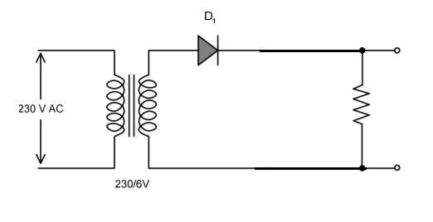](https://www.blogger.com/blog/post/edit/874561140284388880/2341752415980545344)

Components:

1) Step-down transformer

2) diode

3) load (resistance)

Diode conducting during the positive half-cycle:

[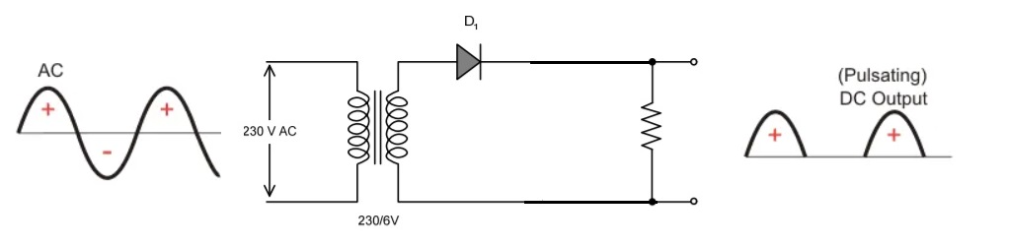](https://www.blogger.com/blog/post/edit/874561140284388880/2341752415980545344)

Diode conducting during the negative half-cycle:

[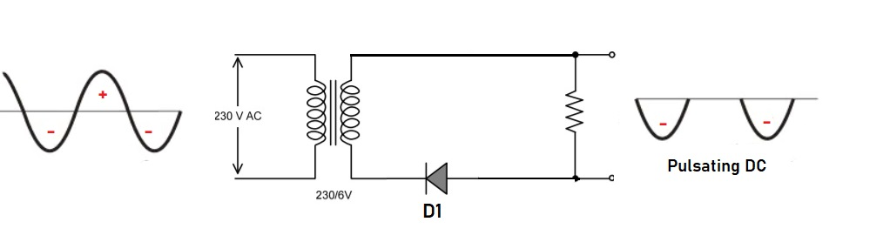](https://www.blogger.com/blog/post/edit/874561140284388880/2341752415980545344)

But we can not get pure DC through the single diode (half-wave rectifier). The DC obtained by a half-wave rectifier is pulsating DC. There are up-downs in this DC and these up-downs are known as ripples.

|  |  |  |
| --- | --- | --- |
| Sr.No. | Parameters | Half wave rectifier |
| 1 | DC load current | Imax/π |
| 2 | RMS load current | Im/2 |
| 3 | Efficiency | 40.6% |
| 4 | Ripple | 1.21 |
| 5 | Transformer utilisatiion factor | 28.7% |
| 6 | No. of diodes | 1 |
| 7 | Peak inverse voltage | Vm |
| 8 | Core saturation | Possible |

**Calculations:**

**1)         1) Average value(dc value):**

      It is the average value of dc voltage when maximum voltage is divided by the half cycle.

[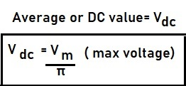](https://www.blogger.com/blog/post/edit/874561140284388880/2341752415980545344)

**2)      2) RMS value(root mean square value):**

       The root mean square value can be obtained by dividing the maximum voltage value by 2.

[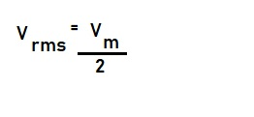](https://www.blogger.com/blog/post/edit/874561140284388880/2341752415980545344)

**3)      3) Form factor:**

       This is the ratio of RMS value to Dc value

[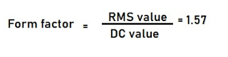](https://www.blogger.com/blog/post/edit/874561140284388880/2341752415980545344)

Form factor = 1.57

**4)     4) Ripple factor:**

       Rectifier consist of AC as well as DC component after rectification. These pulses after the rectification are known as ripples. The ripple factor can be explained as:

**=**

[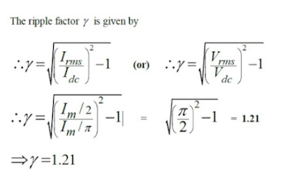](https://www.blogger.com/blog/post/edit/874561140284388880/2341752415980545344)

**5)     5)  Rectification efficiency:**

 It is defined as the ratio of DC power delivered to AC output from transformer.

[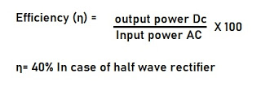](https://www.blogger.com/blog/post/edit/874561140284388880/2341752415980545344)

**6)      6) Transformer utilization factor: 28.7%**

**7)      7) Peak inverse voltage:**

       It is the maximum voltage which appears across the diode during non-conducting state or in Off state.

[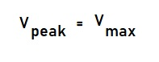](https://www.blogger.com/blog/post/edit/874561140284388880/2341752415980545344)

PIV(peak inverse voltage) = max voltage (Vm)

To reduce the ripples from the output we can use filters. Which help to remove the unwanted AC component from the output.

**FILTER:**

 The filter is a type of circuit that is used to remove unwanted AC for this we can use a capacitor, in parallel with the output. Using a capacitor as a filter is very effective because through this unwanted AC is grounded and we will get a suitable output DC waveform.

Capacitor: blocks DC but AC can pass through this.

[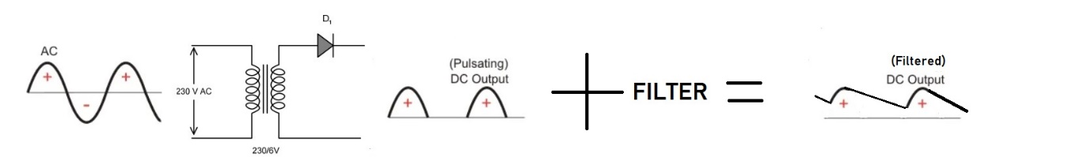](https://www.blogger.com/blog/post/edit/874561140284388880/2341752415980545344)

This DC waveform is still not good, we can use inductors in series with the circuit so that it will block the AC component by induction. But inductor filter is not suitable in a half-wave rectifier.

[**Full-wave rectifier schematics and Gerber files (PCB layout)**](https://www.blogger.com/blog/post/edit/874561140284388880/2341752415980545344)

[**Audio amplifier rectifier schematics and Gerber files (PCB layout)**](https://www.blogger.com/blog/post/edit/874561140284388880/2341752415980545344)

**How to order PCB from JLCPCB:**

**1) Download the files given above and visit**[**JLCPCB.COM**](https://www.blogger.com/blog/post/edit/874561140284388880/2341752415980545344)

"Remember that if you have a project either on a small or large scale, you can upload your designs to [JLCPCB](https://www.blogger.com/blog/post/edit/874561140284388880/2341752415980545344) and they will quickly manufacture your prototype or your mass production so that you can take your projects to the next level! $2 for 5 PCBs， Get more SMT coupons at [JLCPCB](https://www.blogger.com/blog/post/edit/874561140284388880/2341752415980545344) "

[](https://www.blogger.com/blog/post/edit/874561140284388880/2341752415980545344)

**2) Sign up or log in using Google or Email:**

[](https://www.blogger.com/blog/post/edit/874561140284388880/2341752415980545344)

Got exciting rewards by log-in first time.

**3) Upload the downloaded Gerber files:**

**[](https://www.blogger.com/blog/post/edit/874561140284388880/2341752415980545344)**

we can upload Gerber files in ZIP or Rar format and the maximum allowed size of the file is 10 Mega-bytes

**4) Choose the color, quantity and material:**

**[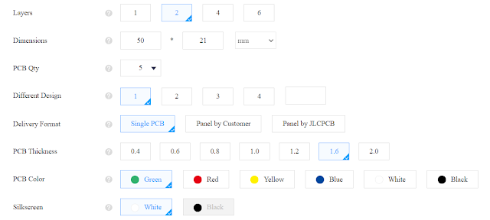](https://www.blogger.com/blog/post/edit/874561140284388880/2341752415980545344)**

**5) $2 for 5 PCB, $5 for 10pcb ( 2 layer):**

**[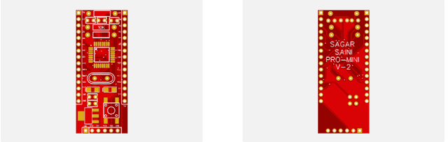](https://www.blogger.com/blog/post/edit/874561140284388880/2341752415980545344)**

**6) Make an order and make payment:**

**[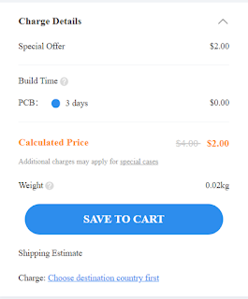](https://www.blogger.com/blog/post/edit/874561140284388880/2341752415980545344)**

**7) After 7 days receive the order.**